Use this .docx file as a template to plan out your final project. Your draft may have a different structure or different elements: add additional rows to this table to clearly share your plans. Replace any my text in blue with your own content.
- Make sure to explain where you’ll have your map, and what 5+ map points you’ll include. (you can write “map point 1” etc in the element box).
- Your project has to have at least five multimedia content blocks (the map counts as one of these)
Add notes to the bottom sharing your ideas about navigation, inclusivity, color/font design, and any questions for your reviewers.
For our peer review workshop, you’ll use “Save as” to convert this file to a pdf for upload to Moodle.

Element | Text |  | Media
Cover | Indigenous Life in Wayne County  Explore the lives of Indigenous communities and today’s reminders of their presence.  Image Citation: A General Map of the Country on the Ohio and the Muskingum. Thomas Hutchinson, 1764. Wikimedia Commons. https://commons.wikimedia.org/wiki/File:Thomas_Hutchins_Map_of_Henry_Bouquet%27s_1764_Expedition.jpg. Public Domain. |  | 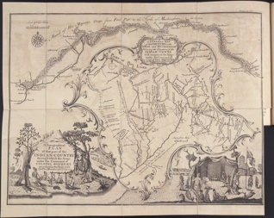
Heading | In the early 1700s, a group of settlers came to Wayne County. They weren't Irish, German, Dutch, or English:
Heading | They were Indigenous.
Paragraph | Looking at Wayne County now, it is hard to imagine what Indigenous peoples' lives were like. Much of this land is now covered by houses, sidewalks, shops, a college campus, and highways. However, spaces that can remind us of these Indigenous populations still exist.  About two centuries ago, Indigenous people from the Wyandotte, Shawnee, Lenape, and other nations hunted, farmed, and traded on the land we now call Wayne County. Some lived in small settlements within the county, while others lived in larger settlements in the greater Ohio region.
Image | Image Citation: Liberty Street in Wooster Ohio, Rlboyer, Wikimedia images https://commons.wikimedia.org/wiki/File:Wooster_downtown2.jpg. Creative Commons 1.0 Universal Public Domain |  | 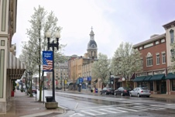
Paragraph | This StoryMap will take you through what life was like for contact-era Indigenous people in Wayne County and show you some sites that reflect the history Wayne County's Indigenous populations. Contact-era means that these Indigenous people interacted with white settlers.
Paragraph | From about 1730 to 1775, several groups of Indigenous people came to Ohio from the eastern seaboard or the South. They hoped to start anew after being removed from their original homelands (Hurt, 10). Once they arrived, they organized settlements and found ways to access food, water, and other goods.
Video embed |  | https://youtu.be/p6k0zSc1utE (see citation below)
Subheading | The Delaware, Shawnee, Wyandotte, and other tribes that lived in Ohio, shared similar lifestyles as they adapted to their new home.
Paragraph | In fact, these tribes created a larger society in the 1700s that interacted with European and American powers and formed a network of agriculture, settlement, and trade (McConnell, 4).
Heading | Settlement
Image | Image Citation: “Indian Village.” Edward A. Collier (1914). Internet Archive Book Images, Wikimedia images https://commons.wikimedia.org/wiki/File:Indian_village_(14781884851).jpg No known copyright restrictions. | “Indian Village”  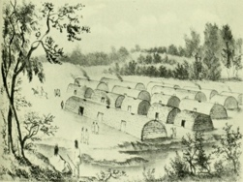
Paragraph | As Indigenous groups moved into the Ohio region, they started settlements that took advantage of Ohio’s water sources and landscapes. Sometimes, these settlements were more permanent, while others moved around and followed sources of food.  Some villages were made up of log houses and wigwams. People often met in a central house to discuss important matters. Indigenous people in Ohio settled along rivers and streams, which were important for transportation and agriculture (McConnell, 5). Land trails also connected villages.
Image -slide show (correspoding with paragrahps above) | Image Citation: Longhouse. Munsee Huron Wendat. Wikimedia Images. https://commons.wikimedia.org/wiki/File:Longhouse_of_huron_wendat.jpg. Creative Commons 4.0.  Image Citation: Allentown Fish Hatchery, Museum of Indian Culture. Allie Caulfield. Wikimedia images. https://commons.wikimedia.org/wiki/File:Lenape_dwelling.jpg. Creative Commons 2.0. | Images of the Longhouse and Lenape Dwelling  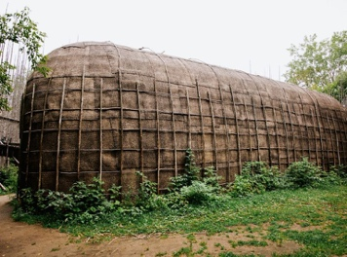  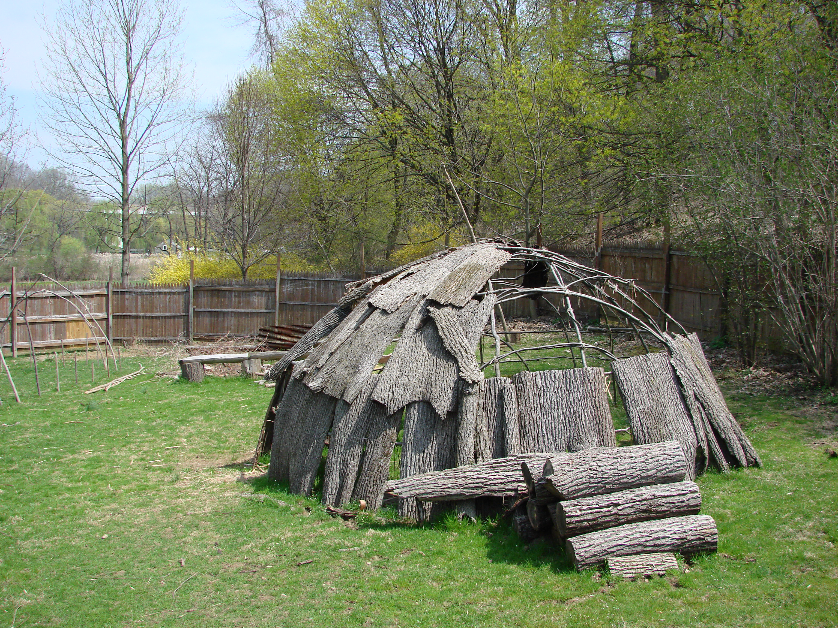
Heading | Settlements in the Area
Map item 1– side car: guided tour with map focus | The closest major settlement to Wayne County was Killbuck’s Town, a Delaware village located on the Holmes-Wayne borderline (Wilger Williams, 3). George Knepper places the town just underneath the borderline in Holmes County (Hurt, 21). This town was first observed by Thomas Hutchins, who accompanied Bouquet’s expedition to put down an Indigenous rebellion led by Pontiac, in 1764. (“Thomas Hutchins,” 2022.) Killbuck is the name of several Delaware figures of the same familial line, including Gelelemend, who supported the United States during the American Revolution (Weslager, 44). Killbuck’s Town lies near Killbuck Creek and the Killbuck Marsh.  Image Citation: “Open Land in the Great Killbuck Swamp of Southwestern Franklin Township, Wayne County Ohio, United States.”Anne-Lise Heinrichs. Wikimedia images https://commons.wikimedia.org/wiki/File:Great_Killbuck_Swamp.jpg. Creative Commons 2.0. | Image: Killbuck marsh  Location: Killbuck marsh  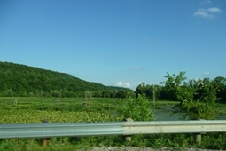
Map item 2– side car | Mohican John’s town, a Mohican/Seneca-Cayuga settlement, was to the west in Ashland County (Hurt, 21). The town was named after Mohican John, a chief who came to Ashland County in 1755 (Bowen, 87). Some members of the Mohican tribe became part of the Seneca-Cayuga after they left New York in thee mid-1700s (“Native Americans and Early Statehood,” 2008). Sometimes they are referred to as the “Mingo” but this is considered an offensive term. (“Seneca-Cayuga”, 2022). | Image: Where Mohican John’s town is noted on the older map or an illustration of the Seneca-Cayuga or approximate site today?  Location: https://www.google.com/maps/@40.832401,-82.2225487,12.84z
Map item 3– side car | When white settlers arrived in Wayne County, they noted the existence of Indigenous settlements. The main local settlement was Beaver Hat Town, which was led by Papellond, a Delaware Chief. Beaver Hat Town also benefitted from its location near the Great Trail, a trade route.  Citation: Oak Hill (Wooster) Cemetery. Scot McLellan. Wooster Digital History Project. https://woosterhistory.org/exhibits/show/indigenoushistory/item/216 Rights held by Scott McLellan, permissions granted. | Image: modern location of where this is in Wayne County from Wooster Digital History Project  Location: Wooster cemetery  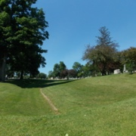
Map item 4– side car | On pages 165 and 166 of Ben Douglass’s History of Wayne County Ohio, the author mentions that Indigenous people were most populous where East Union, Chippewa, Clinton, and Franklin townships are today. Unfortunately, he does not give detailed descriptions of these settlements.  Citation: “West Badger Farm in Wayne County, Ohio is a facility of the Ohio Agricultural Research and Development Center.” Roseohioresident. Wikimedia images. https://commons.wikimedia.org/wiki/File:West_Badger_Farm,_Wayne_County,_Ohio.jpg. Creative Commons 4.0. | Image: East Union Township 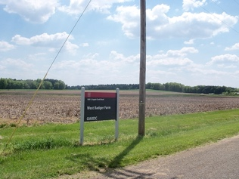
Map item 5- side car | To the south of Wooster, Schoenbrunn village, located where New Philadelphia is today, was home to Delaware people and Moravian missionaries (“Schoenbrunn,” 2022.) The Moravians, who were German missionaries, first scouted out the Muskingum Valley in the 1760s, and in 1772 the Moravians brought a group of Christian Delaware people from Pennsylvania to the Schoenbrunn site (Hurt, 18).  Citation: “Zeisberger Preaching to the Indians,” John Sartain. Library of Congress. No Known Restrictions on Publication. | Image: Ziesberger preaching 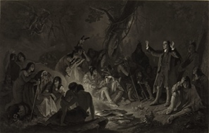
Map item 6 – side car | In Ashland County, Greentown, located where Green township is today, was a more major Delaware settlement in the late 1700s and early 1800s (“Greentown: A Story of 1812 in Contemporary Documents,” Thomas Stephen Neel).  Citation: Greentown Delaware village site east of Mansfield, Ohio. Chris Light. Wikimedia Images. https://commons.wikimedia.org/wiki/File:Greentown_Delaware_Village_P6240085.jpg. Creative Commons 4.0. | Image: Greentown sign 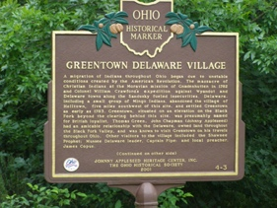
Heading – side car | Indigenous Agriculture
Image – side car | Citation: “Three Sisters.” Garlan Miles. Wikimedia Images. https://commons.wikimedia.org/wiki/File:Three_Sisters_planting_visual_graphic.png. Creative Commons 4.0. | “Three sisters”  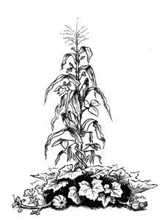
Paragraph – side car | Agriculture was an important part of life for Indigenous people. Indigenous people in the Ohio area enjoyed fertile soil along riverbeds and ample hunting lands (Hurt, 4-5). They grew crops like corn, beans, and squash. They also utilized the lands for hunting which provided food, clothing, and tools (Hurt, 22-23). The white tailed deer was an especially important food source (Hurt, 5).  In these societies, especially the Delaware, women farmed and grew crops, while men hunted (Gunlog Fur, 17-18). In Wyandotte and Shawnee culture, men participated more in farming (Hurt, 22).  While European farmers tended to farm a few fields in the same place, Indigenous people in Ohio travelled from time to time in search of new land. Indigenous people did not believe that land could be bought, sold, or owned (Hurt, 25). They burned their fields occasionally to clear them (6). Ben Douglass mentions that when white settlers arrived, they noticed that some areas had been burned by Indigenous people and white hunters (Douglass, 192).
Map item 5– side car (same map) | Near Apple Creek, a local Delaware chief named Papellond was also known for having a well-kept apple orchard, or “chauquecake” (Douglass, 167). Local historians predict that Johnny Appleseed had some influence in introducing apples to Indigenous people in Wayne County and the surrounding areas in Northeast Ohio. () | Image – apple creek, approximately where the settlement would have been (3 miles east of the cemetery)  Location: 3 miles east of the cemetery
Map item 6 -side car | In settlements run by missionaries, agriculture looked a bit different. Moravian missionaries in Ohio introduced cattle and other livestock (Ziesberger diaries, 69). Indigenous people from other settlements also travelled to Moravian settlements for food during the winter months.  Citation: “Restored Cottages of the Moravian Indians in Schoenbrunn, Ohio.” Ernest Mettendorf. Wikimedia Images. https://en.wikivoyage.org/wiki/File:Restored_cottages_of_the_Moravian_Indians_in_Schoenbrunn,_Ohio.jpg. Public Domain. | Image - Moravian Cabins  Location: Schoenbrunn or closest Moravian missionary site to Wayne County?  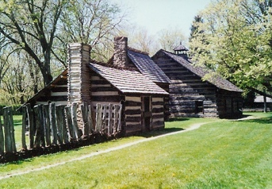
Heading | Trade and Trails
Image | My own image. From the inside cover of Wilcox’s Ohio Indian Trails. | Wilcox Map 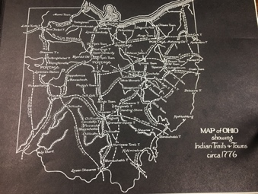
Paragraph | Trade was another vitally important part of Indigenous society. Before they came to Ohio, Indigenous groups like the Delaware traded with the British and French. Indigenous people bought goods from Europeans that had a variety of purposes, such as rifles, metal pots and pans, jewelry, knives, and more (McConnell, 39).
Image | Citation: “An Illustration of European and Indigenous Fur Traders in North America, 1777.” William Faden. Library and Archives Canada and Wikimedia. https://en.wikipedia.org/wiki/North_American_fur_trade#/media/File:Fur_traders_in_canada_1777.jpg. Public Domain in the US and Canada. | Illustration of Trade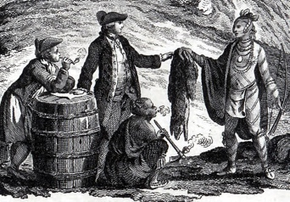
Paragraph | However, trade also brought negative influences like alcohol and conflict (41-42). European traders made sure that their goods fit Indigenous needs and wants, while Indigenous people brought Europeans pelts and furs, or even human captives (Richter, 175; 178).
Paragraph | Rivers and trails connected Ohio’s Indigenous economy. Wooster is situated on two trails that were used for trade, the Great Trail and the War Trail. The Great Trail led to important trading sites such as Logstown while the War Trail was originally forged by the Iroquois (Wilcox, 43-45; 75-77). These trails functioned much like today’s highways for local Indigenous people: they were a means of travel, and they also brought goods from far and wide.
Map item 7 – side car block | In fact, any Indigenous trails follow the same routes of today’s highways. Parts of the Great Trail, for example, follow closely along today’s Route 3 in Wooster (Wilcox, 45).  Ohio State Route 3, Wooster, Ohio. Adam Moss. Flickr, Creative Commons 2.0. https://www.flickr.com/photos/roadgeek/25501669134 | Image: modern route 3  Location: can I highlight an entire highway?  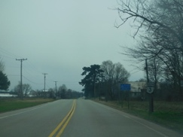
Map item 8 -sidecar block | Meanwhile, parts of the War Trail follow closely with Route 585.  Citation: “Ohio State Route 3.” Doug Kerr. Flickr, Creative Commons 2.0. https://www.flickr.com/photos/dougtone/7208868700 | Image: modern route 585  Location: can I highlight an entire highway?  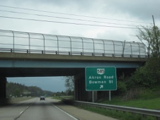
Map item 9 – side car block | Lastly, route 83 follows closely to the Killbuck Path, which led to Killbuck’s Town (Wooster Digital History Project/Wilger Williams)  Citation: “The State Route 83 Wooster Bypass.” Nicholas Eckhart. Flickr. Creative Commons 2.0. https://www.flickr.com/photos/fanofretail/15515638785 | Image: modern route 83  Location: can I highlight an entire highway?  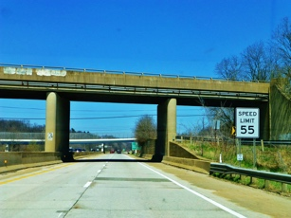
Heading | Conflict with White Settlers
Paragraph | While Indigenous people made their new lives in Ohio, they were increasingly threatened by the approach of white settlers. This often led to conflict, as Indigenous people feared white violence, and white settlers wanted to clear out Indigenous settlements to make room for their own (“Greentown: A Story of 1812 in Contemporary Documents,” Thomas Stephen Neel). Tensions ran high after the Revolutionary War as white squatters poured into Indigenous lands.
Map item 10 – side car block | One locally famous example of conflict in Wayne County is called the Fulkes Massacre, which occurred in the 1790s on the south end of town, close to Beaver Hat Town. It is now commemorated at Schellin Park. During this conflict, Captain Fulkes, a Pennsylvania militia leader, and his men killed sixteen Indigenous (most likely Lenape) men. The cited reason was because this group was supposedly guilty of committing a raid back in Pennsylvania (Wilger Williams, 5). Later, this story would be used by authors like Ben Douglass to demonize all of the Indigenous people who lived in Wayne County.  Citation: my own image. | Image: schellin park (from my phone)  Location: schellin park  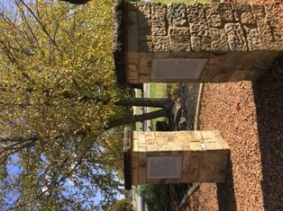
Map item 11 | Similarly, as white settlers began to arrive in the area, conflicts occurred as these two groups sought to understand one another. In the early 1800s, Benjamin Douglass records a story about an explosion at Stibbs’ Mill, which according to Paul Locher was located at the bottom of the hill on Pittsburgh Ave. Douglass blames the explosion on a few Indigenous men who were smoking too close to a keg of gunpowder. (Douglass, 170). (https://www.the-daily-record.com/story/lifestyle/2014/09/19/bits-pieces-9-19-mills/19631547007/) | Image: location on Pittsburgh Ave. or image of Stibb’s mill from WCHS  Location: approximation of the bottom of the hill
Map item 12 | Many of the Indigenous people in this area began to leave amidst the War of 1812. Gen. Beall, whose home is located in Wooster, raided the fort at Jeromesville, near Mohican John’s Town, and took many of the Indigenous inhabitants prisoner (Douglass, 225). According to records from Benjamin Mortimer, a missionary in the area, the contentions caused by the War of 1812 made many Indigenous people flee the area in fear for their lives (“Greentown: A Story of 1812 in Contemporary Documents,” Thomas Stephen Neel) | Image: Beall House  Location: Beall House  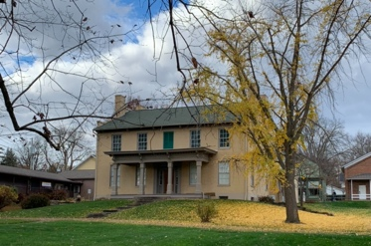
Heading | Conclusion
Paragraph | After making new lives in Wayne County, Indigenous communities faced a wave of incoming white settlers who wanted the land for themselves [hyperlink to IS webpage]. Eventually, these Indigenous communities found themselves forcibly removed and forced into Western states and territories such as Indiana, Kansas, and eventually Oklahoma [hyperlink to my IS webpage] by white settlers and treaties made by the United States Government.  In 1805, the Treaty of Fort Industry officially made this area a part of the United States. Wooster was then declared a town three years later in 1808.  However, the Wyandotte, Shawnee, and Delaware continue to preserve their cultures and ways of life today. Below is a map that illustrates where the Delaware, Shawnee, and Wyandotte currently live.
Map item 13 | Delaware Nation  Image citation: Delaware Nation Seal Vector Logo. Dnpubreldir, Wikimedia images https://commons.wikimedia.org/wiki/File:Delaware-Nation-Seal-Vector-Logo.jpg. Creative Commons 4.0 License. | Photo: logo 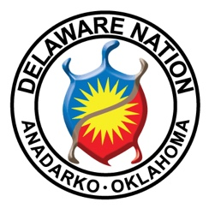
Map 14 | Delaware Tribe of Indians  Image citation: Flag of the Delaware Tribe of Indians. Xasartha, Wikimedia images. https://commons.wikimedia.org/wiki/File:Flag_of_the_Delaware_Tribe_of_Indians.PNG. Creative Commons 3.0. | logo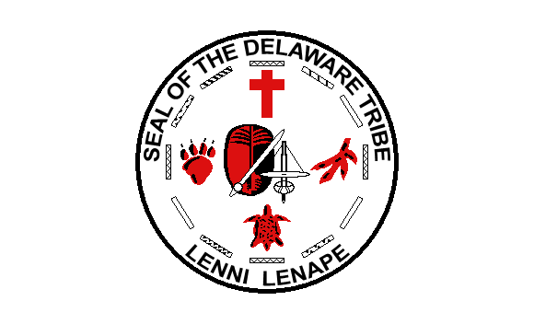
Map 15 | Shawnee Nation  Image Citation: Flag of the Shawnee Tribe. Himasaram. Wikimedia images. https://en.wikipedia.org/wiki/File:Flag_of_The_Shawnee_Tribe_of_Oklahoma.svg. Public Domain. | Logo 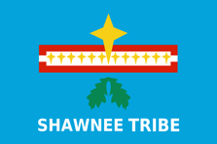
Map 16 | Eastern Shawnee  Image Citation: Flag of the Eastern Shawnee Tribe of Oklahoma. Xasartha. Wikimedia images https://commons.wikimedia.org/wiki/File:Flag_of_the_Eastern_Shawnee_Tribe_of_Oklahoma.PNG. Creative Commons 3.0. | Logo 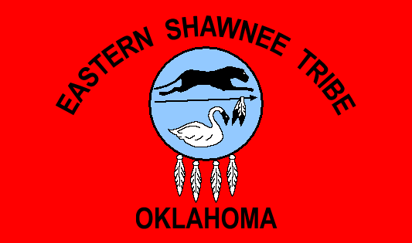
Map 17 | Wyandotte  Image Citation: Flag of the Wyandotte Nation of Oklahoma. Xasartha. Wikimedia images https://en.wikipedia.org/wiki/File:Flag_of_the_Wyandotte_Nation_of_Oklahoma.PNG. Creative Commons 3.0. | Logo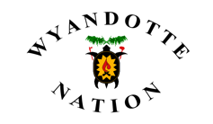
Map 18 | Seneca-Cayuga  Image citation: Flag of the Seneca-Cayuga Tribe of Oklahoma. Xasartha. Wikimedia images https://en.wikipedia.org/wiki/File:Flag_of_the_Seneca-Cayuga_Tribe_of_Oklahoma.PNG. Creative Commons 3.0. | Logo  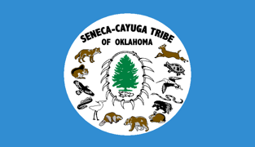
Credit block | This project was made as a part of my 2022-2023 Independent Study. Click here [hyperlink] to view the rest of my project. Sources:  - One State Many Nations . YouTube. PBS Western Reserve, 2011. https://youtu.be/p6k0zSc1utE.  - Hurt, R. Douglas. The Ohio Frontier: Crucible of the Old Northwest Indiana University Press, 1996. http://www.jstor.org/stable/j.ctt1zxz1gb  - McConnell, Michael N., A Country Between: The Upper Ohio Valley and Its Peoples, 1724-1774. Lincoln: University of Nebraska Press, 1992.  - Wilger Williams, Lindsey. Old Paths in the New Purchase. Wooster, OH: Atkinson Printing, 1983.  - “Thomas Hutchins.” Thomas Hutchins - Ohio History Central. Accessed November 10, 2022. https://ohiohistorycentral.org/w/Thomas_Hutchins  - Bowen, B.F., ed. History of Wayne County, Ohio, Google Books 1. Vol. 1. 2 vols. Indianapolis, IN: B.F. Bowen & Co., 1910. https://www.google.com/books/edition/History_of_Wayne_County_Ohio/b2cinQEACAAJ?hl=en&gbpv=0.  - Douglass, Ben. History of Wayne County, Ohio, from the Days of the Pioneers and the  First Settlers to the Present Time. Indianapolis, Ind: R. Douglass, 1878. http://archive.org/details/cu31924028848765.  - “Schoenbrunn.” Schoenbrunn - Ohio History Central. Accessed November 10, 2022. https://ohiohistorycentral.org/w/Schoenbrunn.  - “Greentown: A Story of 1812 in Contemporary Documents,” Thomas Stephen Neel  - Fur, Gunlog. Nation of Women: Gender and Colonial Encounters among the Delaware Indians. Philadelphia, PA: Univ Of Pennsylvania Pr, 2012.  - Olmstead, Earl P., David Zeisberger, and George Knepper. David Zeisberger a Life among the Indians. Ashland, OH: The Kent State University Press, 2013.  - Richter, Daniel K. Facing East from Indian Country: A Native History of Early America. Cambridge, MA: Harvard University Press, 2003.  - Wilcox, Frank. Ohio Indian Trails: Pictorial Survey of the Indian Trails of Ohio Arranged from the Works of Frank Wilcox. Ashland, Ohio: Kent State University Press, 2015.  - Knepper, George W. Ohio and Its People. Kent, Ohio: Kent State University Press, 2003.  - Columnist, ANN GASBARRE. “Bits and Pieces 9-19: Mills Were Big Part of Early Wooster History.” Wooster Daily Record. The Daily Record, September 19, 2014. https://www.the-daily-record.com/story/lifestyle/2014/09/19/bits-pieces-9-19-mills/19631547007/.  - Weslager, C. A. The Delaware Indians; A History. New Brunswick, NJ: Rutgers University Press, 1972.  - “Seneca-Cayuga.” Seneca-Cayuga - Ohio History Central, 2022. https://ohiohistorycentral.org/w/Seneca-Cayuga.  - “Native Americans and Early Statehood.” Black, white & beyond: Multiculturalism in Greater Akron, an interactive history. University of Akron, 2008. https://learn.uakron.edu/beyond/nativeam_earlystate.htm#:~:text=The%20Mingos%20were%20an%20Iroquoian,a%20few%20non%2DIroquoian%20Mohicans.

Font/color ideas: I want my font and color scheme to be based off of my site (on-this-land.collegeofwooster.net), so I will use an off-white background, navy blue text, and a navy blue accent. While a serif font may match my content's look and time period, it’s also harder to read. I am also matching the logo to my site.
Navigation ideas: This StoryMap is going to be split up into a few different sections: settlement, agriculture, trade, conflict, and an afterward section. Clicking on the headings above will allow you to jump directly to that section. This StoryMap will then be linked to the rest of my IS (hosted in WordPress) and opened in a new tab.
How is your design inclusive?: My design is inclusive because it features a simple color scheme, sans serif text, and images that include alt text as well as a video with captions. My map is also about an inclusive topic as it is giving new detail to Indigenous life in Wayne County, Ohio.
Questions/requests for peer reviewers:
- I would appreciate if folks gave me some thoughts on the video. It seems to be locally produced in Ohio, with mainly tribal websites and the Ohio History Connection as its sources (https://web.archive.org/web/20041016110511/http://www.pbs4549.org/onestate/hotlist.htm) but I want to make sure it adds something to my site. The acting is sort of corny and it could very well be viewed as stereotyping.
- If you had to cut out map elements especially, which ones would you cut and why? Should my focus just be the settlements in Wayne County and the ones that are closest (Mohican John and Killbuck Town?)
- After reading through my exhibit, is anything unclear? Is there anywhere where I’m providing too much/not enough info? I’ve been steeped in this information for a while, so if you know nothing about Indigenous history, what more would you want to know? Keep in mind that this is part of a larger project, so I have places where I go into more detail about each tribe, the War of 1812, Treaties, removal history, etc.
- How would you summarize the story I am telling? Is there a narrative arc that jumps out at you? Are there ways that I can improve the arc of the story?

Images I still need:
-apple creek
-Pittsburgh ave.
-Mohican john’s town

